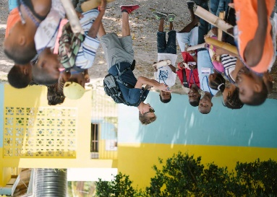
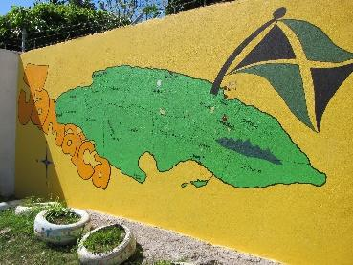
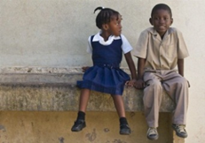
2024 Jamaica ACE Mission Trip

When: June 22 – 29, 2024
Who: This trip is open to church members who are high school students, college students and adults. Possible exceptions to age requirement available upon request.
What: We’ll be working in partnership with ACE, American Caribbean Experience. Check out the work that ACE is involved in at https://www.acexperience.org/. American-Caribbean Experience is a Christ-based outreach ministry dedicated to community transformation in the parish of St. Mary, Jamaica, through strategic initiatives in key areas,including education, enterprise, discipleship and healthcare. They have also provided us with a Trip Agenda outline of what you can expect the week in Jamaica will look like.
Where: St. Mary’s Parish, Jamaica
St. Mary’s is the poorest parish in Jamaica but is also one of the safest. We will be staying at the Galina Breeze Hotel, one of ACE’s micro-businesses. You can see all about the hotel on the ACE website. Most of our meals will be eaten at the Hotel. All our work locations will be within St. Mary’s Parish.

Travel: We will fly from Atlanta or Charlotte to Montego Bay. Once we arrive in Jamaica, we will take a 2-hour van ride to St. Mary’s Parish. While in Jamaica, we will be traveling in ACE vans with their drivers.
Cost: $1,100 per person, this is all-inclusive; airline tickets, travel within Jamaica, all meals, lodging, travel insurance and program costs. Deposits of $100 will be due by November 15th.
Requirements:
- Passport- If you do not have a passport, go on and apply for one now.
  - Need by November 15th
- Application for trip – will hand these out and need them filled out.
- Immunizations- Speak with your doctor about immunizations recommended for travel to Jamaica. A current tetanus shot is the only thing required.
- NO Cell phones and alcohol
  - Attendance and participation in trip meetings and planning sessions.

